Validation of Fine-tuned Large Language Models for Automated Requirement Extraction from Emergency Call Conversations
Abstract
Emergency response systems depend on fast and accurate decisions during critical time periods, where even small delays can affect survival. This paper studies the use of fine-tuned Large Language Models (LLMs) to automatically extract emergency requirements from unstructured and noisy call transcripts. Unlike normal datasets, emergency conversations are incomplete, chaotic, and contain stress-related language, making extraction more difficult. Four open-source LLMs (Gemma 3, Llama 2, Mixtral 2, and DeepSeek-R1) are evaluated based on requirement accuracy and inference latency. Results show that Gemma 3 achieves the best performance with 98.5% accuracy and low latency of 5.2 seconds, making it suitable for real-time use. In contrast, DeepSeek- R1 shows higher reasoning ability but fails in latency-critical scenarios. The study also proposes a real-time chatbot assistant to support dispatchers by providing instant recommendations. Overall, the work shows that lightweight LLMs can be effectively used in emergency systems.
1. Introduction
Emergency response systems are the critical backbone of public safety. Rapid and accurate decision-making during the "golden minute" of a 112 call dictates survival outcomes. Currently, human dispatchers manage this immense cognitive load but can become overwhelmed during large-scale disasters or concurrent emergencies. Large Language Models (LLMs) present a promising avenue to automate the extraction of "requirements", the specific operational and medical needs of the caller, directly from conversational text [1].
However, emergency dialogues pose unique challenges. They are often chaotic, structurally incomplete, and noisy, differing vastly from the clean corpora used for model pre-training. Furthermore, requirement extraction necessitates advanced logical deduction to infer implicit, unspoken needs, such as environmental hazards and urgency levels [3]. Beyond passive extraction, there is a critical need for systems that actively assist operators in real-time.
This study investigates the performance of four state-of-the-art open-source LLMs (Gemma 3, Llama 2, DeepSeek-R1, Mixtral 2). We focus on autonomous decision-making based on raw transcripts, deliberately excluding dispatcher behavioral variables to isolate the models' linguistic and logical capabilities, and subsequently demonstrate how the top-performing model can power a parallel chatbot assistant.
1.1 Research Objectives
This study is guided by four core objectives:
- Performance Evaluation: Benchmark accuracy in identifying both explicit requests and highly implicit emergency requirements.
- Latency Analysis: Analyze inference speeds to establish viability for time-critical PSAP environments.
- Real-Time Chatbot Prototyping: Develop a framework where the fine-tuned LLM acts as a parallel chatbot assistant, translating extracted data into immediate dispatcher recommendations.
2. Related Work
2.1 AI in Crisis Management
A growing body of research explores AI in crisis response architectures. Otal and Canbaz [1] demonstrated LLMs streaming multi-source information processing, effectively acting as an informational triage system. LLMs have also been utilized to simulate high-fidelity dispatcher training environments [2] and optimize vehicle routing across smart cities [4]. While VoiceBench [5] benchmarked standard voice assistants, emergency calls present acoustic and semantic complexities far exceeding standard queries [8]. Other frameworks address traffic incidents [6], crime prediction [7, 9], and equitable disaster response [10].
2.2 Validation in Critical Domains
While theoretical LLM applications in emergencies are well-documented, rigorous validation for life-critical extraction remains underexplored. In software engineering, the "generator-validator gap" highlights how generative models can produce highly plausible text that fails domain-specific constraints [11, 12]. In safety-critical systems, validation requires assessing strict semantic fidelity, factual consistency, and reasoning accuracy under non-negotiable latency constraints [13]. Our work bridges this gap by validating fine-tuned LLMs against a highly structured requirement extraction taxonomy.
3. The Nature of Emergency Requirements
Emergency requirements are inherently fluid and evolve with context, often within seconds. Unlike conventional requirement engineering, where inputs are structured and deliberate, emergency scenarios are reactive, incomplete, and emotionally charged. For analytical clarity, these requirements can be loosely organized into three operational domains:
- Medical Requirements – These relate to immediate health conditions of victims. They include interventions such as Basic Life Support (BLS), Advanced Life Support (ALS), trauma care, or specialized medical teams. These requirements are often partially stated or entirely implied through symptoms described in distress.
- Logistical and Resource Requirements – This domain includes the physical assets needed at the scene, such as ambulances, fire units, cranes, rescue boats, or hazardous material containment units. The complexity here lies in mapping situational cues (e.g., “vehicle submerged”) to appropriate multi-resource deployment.
- Environmental and Safety Requirements – These involve contextual hazards that may not be directly articulated but significantly influence response strategy. Examples include fire risks, water currents, toxic exposure, structural instability, or presence of weapons. These requirements are subtle and demand situational awareness beyond literal text.
Such categorization is not rigid; overlaps frequently occur. A single utterance may simultaneously trigger all three domains, making real-time extraction a non-trivial cognitive task even for trained professionals.

3.1 Challenges in Extraction (Implicit Needs)
The central difficulty in requirement extraction lies not in identifying what is said, but in understanding what is not said. Emergency callers rarely provide structured or complete information. Speech is fragmented, emotionally distorted, and often guided by panic rather than logic. A recurring challenge is implicit inference. The system must bridge the gap between surface-level statements and underlying operational needs. For instance, phrases like “he’s not moving” or “there’s smoke everywhere” do not explicitly request medical or fire services, yet they strongly imply critical interventions. This demands a hybrid reasoning ability combining commonsense understanding, physical world knowledge, and domain-specific heuristics.
Another complication arises from linguistic noise. Fillers, repetitions, incomplete sentences, and even contradictions are common. Traditional NLP pipelines tend to filter such noise, but in emergency contexts, these artifacts may encode urgency or cognitive stress. Ignoring them can degrade situational awareness. Further, there exists a problem of over-generalization versus precision. Models often exhibit a bias toward action, leading to over-dispatching of resources. While this may appear safe, it is operationally inefficient and can strain limited infrastructure. Conversely, under-extraction of requirements can be life-threatening. Striking this balance is inherently difficult. Lastly, temporal constraints impose a strict boundary. Unlike offline reasoning tasks, the model must infer, decide, and output within seconds. Complex reasoning chains, though accurate, become impractical when latency exceeds acceptable thresholds
The most technically demanding challenge lies in identifying implicit requirements. For instance, if a panicked caller states, "The car is upside down in the water, I think they are trapped!", the model must autonomously infer for example, Requirement as Divers/Water Rescue Team; Heavy-duty tow truck with an extraction crane; Advanced Life Support (ALS) ambulance etc. The model must logically deduce these needs even without explicit requests, demanding a level of common-sense physics and foundational medical knowledge beyond legacy rule-based AI.
4. Methodology
We developed a structured end-to-end pipeline utilizing a synthetic dataset of emergency call transcripts and expert-annotated requirement tags.
4.1 Model Selection
Our selection of four LLMs was driven by strict operational criteria: Local Deployability (for strict data privacy), Parameter Efficiency (for low latency on edge hardware), and Architectural Diversity.
- Gemma 3 (7B): A highly efficient transformer with distilled reasoning capabilities.
- Llama 2 (7B): A robust, industry-standard foundational model.
- DeepSeek-R1: Optimized for complex, multi-step reasoning via RLHF.
- Mixtral 2 (7B): A Sparse Mixture-of-Experts (MoE) model designed for high performance with lowered latency.
4.2 Data Pipeline and Fine-Tuning Process
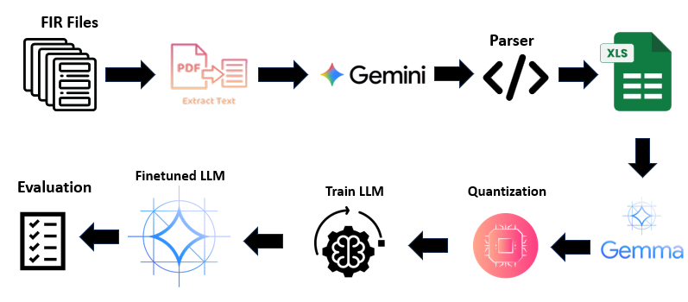
Figure 1: LLM Fine tuning pipeline
The workflow begins by cleaning raw First Information Reports (FIRs) and synthetic transcripts. A baseline Gemini model parses this chaotic text into rigid categories (e.g, incident type, location) before formatting it into uniform tables (XLS). During supervised fine-tuning (SFT), the target models learn to map noisy transcript patterns to these structured outputs. Post-training, we applied quantization (4-bit) to drastically reduce memory footprint, a mandatory optimization for local edge hardware deployment.
4.3 Preprocessing for Stress Indicators
Our pipeline deliberately retained linguistic noise like "filler words" (e.g, um, ah), expletives, and fragmented sentences. Rather than treating these as disposable data, we utilized them as vital acoustic markers of caller cognitive stress to accurately determine the incident's Urgency requirement.
- Validation Framework
  - Existing Evaluation Metrics
  - Evaluation of Large Language Models, particularly in conversational or decision-support systems, is typically structured along two broad dimensions: performance latency and output validity. While these metrics are widely adopted in chatbot and general NLP systems, their applicability to emergency requirement extraction remains only partially sufficient.
  - From a system standpoint, latency-oriented metrics quantify responsiveness and deployment feasibility. Measures such as Time to First Token (TTFT) capture the delay before generation begins, whereas Time per Output Token (TPOT) and Inter-token Latency (ITL) describe the consistency of streaming outputs. More comprehensively, End-to-End latency evaluates the total response time from input to final output. In parallel, throughput (tokens processed per second) reflects system scalability under concurrent workloads. These metrics are widely discussed in LLM serving and benchmarking literature, particularly in inference optimization studies [5, 8].
  - On the validation side, quality-oriented metrics assess correctness and reliability of generated responses. Classical measures such as accuracy and Exact Match (EM) are frequently used in structured prediction tasks, while task success rate evaluates goal completion in interactive systems. In generative pipelines, factuality and faithfulness become critical, especially in Retrieval-Augmented Generation (RAG) frameworks where outputs must remain grounded in external knowledge sources [11, 12].
  - Linguistic evaluation further introduces metrics like perplexity, which estimates model uncertainty, along with qualitative assessments of coherence and fluency. More recent studies emphasize safety and alignment metrics, capturing hallucination rates, bias, and unintended disclosure of sensitive information [13]. Additionally, user-centric metrics, such as escalation rate and self-service resolution, have been proposed to approximate real-world effectiveness of deployed systems [3, 16].
  - However, prior work in LLM evaluation—especially in domains like software requirements and safety-critical AI—highlights a persistent limitation. The generator–validator gap demonstrates that models may produce fluent yet operationally incorrect outputs, thereby exposing weaknesses in conventional evaluation schemes [11]. Similarly, domain-specific studies in requirement extraction indicate that standard NLP metrics fail to capture semantic completeness and logical correctness under constrained environments [12].
  - In the context of emergency response, these limitations become more pronounced. Existing metrics largely emphasize linguistic quality or general correctness, but do not adequately account for contextual criticality, where omission of a single requirement may outweigh multiple correct predictions. Furthermore, they rarely penalize resource over-generation, which can strain already limited emergency infrastructure.
  - Consequently, while existing evaluation metrics offer a useful baseline, they require domain-specific refinement to address the dual constraints of high-stakes decision accuracy and strict real-time latency, as also noted in recent safety-critical AI evaluation frameworks [13].

We prioritized two primary, domain-specific validation criteria:
- Requirement Accuracy (RA): Evaluates whether the model correctly identified all explicit and implicit requirements without hallucinating unnecessary resources. Penalties were applied for both missing vital requirements and over-dispatching (which depletes municipal resources).
- Decision Latency: The absolute end-to-end inference time. Strict latency thresholds (single-digit seconds) were enforced to simulate the "golden minute" standard.
6. Experimental Results and Analysis
6.1 Quantitative Comparison
Model | Accident Type Accuracy (%) | Resource Prediction (%) | Vehicle Error Rate | Latency
Gemma 3 (7B) | 98.5 | 98.0 | 0.24 | 5.2 sec
Llama 2 (7B) | 96.5 | 94.5 | 0.33 | 10.3 sec
Mixtral 2 (7B) | 91.5 | 87.5 | 2.20 | 11.5 sec
DeepSeek-R1 | 88.5 | 71.5 | 2.32 | 2.5 min
Table 1 demonstrates that Gemma 3 (7B) achieved the strongest cohesive performance. It secured 98.5% accident type accuracy and 98.0% resource prediction while maintaining a highly practical latency of 5.2 seconds. Llama 2 (7B) performed competently (96.5% accuracy) but its 10.3-second latency could bottleneck fast-paced dispatch systems. Mixtral 2 struggled with complex resource prediction (87.5%) and granular vehicle details, suggesting its sparse MoE architecture may drop context.
Despite its design for profound reasoning, DeepSeek-R1 significantly underperformed in this rapid-extraction task (88.5% accuracy). Most critically, its 2.5-minute chain-of-thought latency renders it operationally useless for live emergency environments.
6.2 ROC Curve Analysis
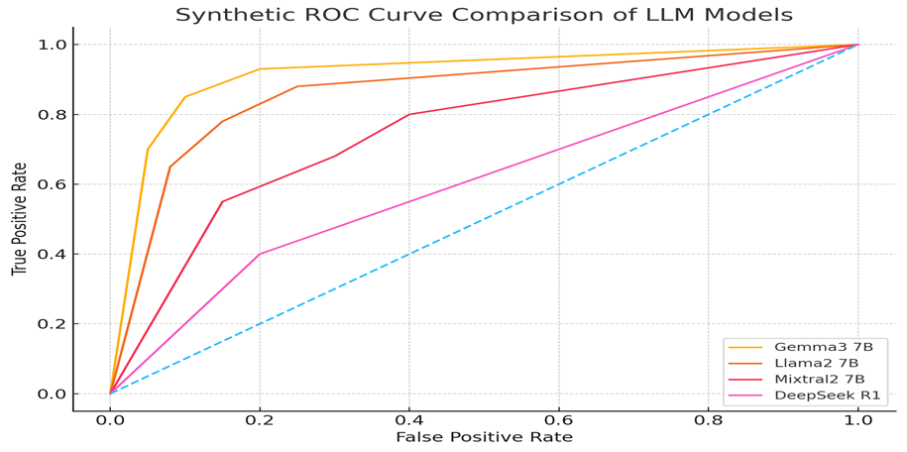
Figure 2: Synthetic ROC Curve Comparison of LLM Models
Figure 2 illustrates the Receiver Operating Characteristic (ROC) curves. Gemma 3's curve remains firmly pinned to the top-left, indicating an exceptionally high True Positive Rate with minimal False Positives. Conversely, DeepSeek-R1 dangerously approaches the diagonal baseline, indicating weak discriminative capability for this fast-paced classification paradigm.
7. Discussion
Models frequently struggled with "Negative Requirements" due to an inherent bias toward action. For example, if a patient is "breathing, but not awake," the model must prioritize a Neurological Assessment while actively avoiding CPR instructions. To mitigate harmful medical hallucinations, our top-performing models were integrated with a Vector-based retrieval system that cross-referenced outputs against official Standard Operating Procedures (SOPs) [6]. Requirement extraction is an exercise in logical deduction under extreme time constraints. While DeepSeek-R1's reasoning protocols theoretically reduce hallucinations in academic settings, its latency penalty is fatal in emergency medicine. Distilling the multi-step reasoning of models like R1 into the lightweight inference architectures of models like Gemma 3 remains a critical future challenge.
8. Real-Time Implementation Considerations
8.1 The Parallel Chatbot Assistant Interface
Building directly on top of the streaming extraction module, we developed a real-time AI "chatbot" or dispatch assistant. Rather than merely outputting passive JSON arrays of requirements, the fine-tuned LLM operates in parallel with the live call, acting as an active copilot for the dispatcher.
As the caller speaks, the assistant immediately populates a conversational UI on the dispatcher's screen with actionable recommendations. For instance, if the LLM detects the keyword "gun" buried in a frantic sentence, the chatbot instantly flashes a high-priority alert: "Weapon detected. Recommend asking caller if the suspect is still on the premises, and dispatching armed units." This parallel analysis ensures that dispatchers, who may be focused on calming the caller, do not miss critical contextual clues, effectively reducing human cognitive overload.
8.2 Edge Deployment vs. Cloud
Implementing this chatbot infrastructure requires localized "Edge" computing. Transmitting unredacted emergency audio to cloud-based LLMs introduces unacceptable network latency and violates stringent data privacy regulations. Smaller 7B parameter open-weights models (like Gemma 3) are advantageous because they can be hosted locally on standard enterprise GPUs, ensuring complete data sovereignty and lightning-fast inference for the chatbot UI.
9. Conclusion
This study establishes that fine-tuned LLMs can effectively automate the extraction of life-saving requirements from unstructured, high-stress emergency call transcripts. Furthermore, they can serve as the foundation for active, real-time chatbot assistants that operate in parallel with human dispatchers.
Gemma 3 (7B) offers the most stable and practical performance, coupling exceptional accuracy (98.5%) with an operationally viable latency (5.2 seconds). Conversely, while heavy-reasoning models like DeepSeek-R1 excel in theoretical logic, their multi-minute inference times render them unsuited for live crisis management or real-time chatbot integration.
Emergency requirement extraction demands robust resilience against severe linguistic noise. Future work must transition to real-world, multi-lingual audio streams. Furthermore, exploring hybrid architectures, where a lightweight model handles live chatbot extraction, while a heavier reasoning model conducts asynchronous post-call QA auditing, could fully realize the AI-assisted emergency dispatch ecosystem.
References
[1] H. T. Otal and M. A. Canbaz, "AI-Powered Crisis Response: Streamlining Emergency Management with LLMs"
[2] Z. Chen, et al., "Sim911: Towards Effective and Equitable 9-1-1 Dispatcher Training with an LLM-Enabled Simulation"
[3] H. T. Otal, E. Stern, and M. A. Canbaz, "LLM-Assisted Crisis Management: Building Advanced LLM Platforms for Effective Emergency Response and Public Collaboration"
[4] R. Chen, et al., "An LLM-driven Framework for Multiple-Vehicle Dispatching and Navigation in Smart City Landscapes"
[5] Y. Chen, et al., "VoiceBench: Benchmarking LLM-Based Voice Assistants"
[6] A. Ahmed, et al., "From Detection to Action: A Multimodal AI Framework for Traffic Incident Response"
[7] H. N. Nakayenga, et al., "Leveraging AI for real time crime prediction, disaster response optimization and threat detection to improve public safety and emergency management in the US"
[8] Z. Yang, et al., "Talk2Care: An LLM-based Voice Assistant for Communication between Healthcare Providers and Older Adults"
[9] S. Huo, et al., "Crash Scene to Resolution: LLM-based Agents Driven for Efficient Traffic Accident Handling"
[10] O. Odubola, et al., "AI in Social Good: LLM powered Interventions in Crisis Management and Disaster Response"
[11] M. Rodriguez, et al., "The Generator-Validator Gap in AI Evaluation for Software Engineering," (2025).
[12] H. Marques, et al., "From Elicitation Interviews to Software Requirements: Evaluating LLM Performance in Requirement Generation," (2025).
[13] D. P. Panagoulias, "A framework for evaluation and requirement extraction for fine-tuning of Large Language Models in multimodal medical diagnosis," Knowledge-Based Systems (2025).

